Welling United FC Academy
Tournament Application Form
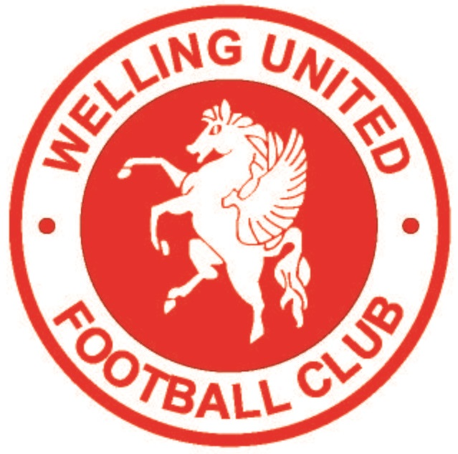

Club Name
County FA Code |  |  | Affiliation Code
Team Contact  Name:  Address:  Postcode:  Email:  Telephone |  |  | Club Secretary  Name:  Address:  Postcode:  Email:  Telephone:
Please ensure that email addresses are clear for all correspondences.
Team name submitted for each age group
Saturday 22nd June (AM) |  |  | Saturday 22nd June (PM)
Under 10 |  |  | Under 8
Under 14 |  |  | Under 12
Under 15
Sunday 23rd June (AM) |  |  | Sunday 23rd June (PM)
Under 9 |  |  | Under 7
Under 13 |  |  | Under 11
Under 16
Team Colours Shirts: Shorts:
Please note under FA rules that a player who has not obtained the age of 6 at midnight on 31st August 2017 is not allowed to play in this tournament.
Cheque enclosed made payable to Welling United FC Academy for £30 per team for U7 – U10, £35 per team for U11 - U16.
NB. Please submit a form per team if submitting more than one team for the same age group.
Closing date is 30th April 2019
Please send all completed forms to the tournament organiser:
Neil Lewis, Welling United, 21 Rocks Close, East Malling, Kent ME19 6A

